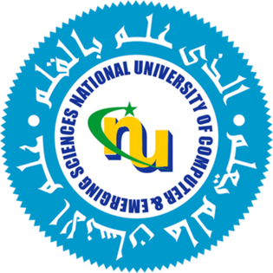

**Professional Practices in Information Technology**

**Indus Motor Company**

Project Proposal

Mohammad Yehya – K213309

Daniyal Haider – K13433

Hasan Iqbal – K213297

**Project Abstract**

This project aims to explore and document the current practices and organizational structure of Indus Motor Company (IMC). By visiting the company, conducting interviews, and observing workplace processes, we seek to gain insights into its operational methodologies, hierarchy, and management strategies. The study will focus on identifying key elements contributing to IMC's success in the automotive industry, as well as any challenges it faces in adapting to emerging trends. The resulting report will serve as a comprehensive case study, providing valuable lessons for business operations, organizational efficiency, and industry-specific practices.

**Expected Outcomes**

1. A detailed report on IMC's organizational structure and current practices.
2. Insights into the strategies contributing to IMC's market position.
3. Recommendations (if applicable) for potential improvements or innovations.
4. A framework for understanding similar organizations in the automotive industry.

**Target Person**

The person we have aimed to target is “Sheeba Shahid” (<https://www.linkedin.com/in/sheeba-shahid-0469951a3/>) from the company. She is currently the “Assistant Manager Digitalization and AI - Innovation Engineering Department” in the company for about 1 year. Before that, she was “Assistant Manager Projects” for almost 1.9 years.